Completing the Counties Connection Class
Using the DataConnection

Using the DataConnection 1
clsDataConnection 3
Creating the Data Connection Class File 4
Azure Connect 7
Connection Strings and Public Git Repositories 7

Using the DataConnection
You should by this stage have a server set up on Azure, with a database called AddressBook, a table called tblCounty and a stored procedure called sproc_tblCounty_SelectAll...
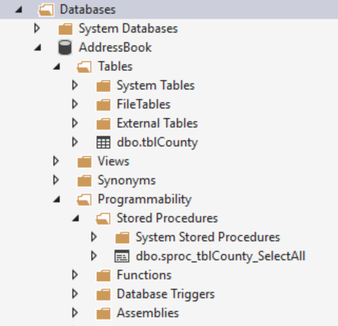
The table contains a list of UK counties…
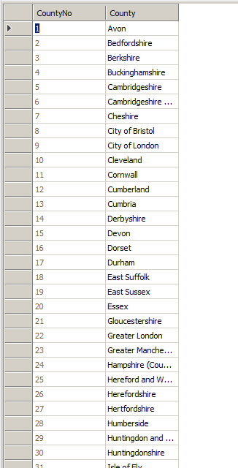
The stored procedure called sproc_tblCounty_SelectAll contains the following SQL…
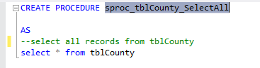
You will now need to go back and re-open the work you started prior to being distracted by Azure.
So what we want to do is re-factor the code for the constructor for clsCountyCollection such that it links to and draws data from this stored procedure.
As things stand the code generating the list on the interface...
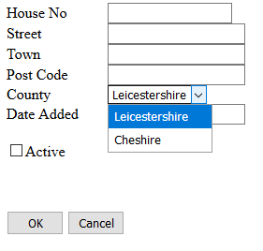
Is hard coded into the following function (the constructor for the class)...
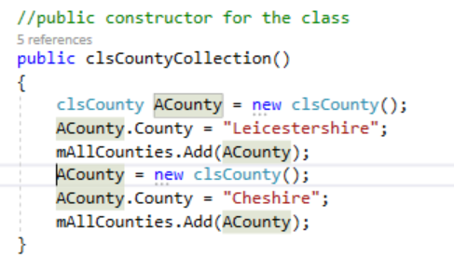
This code needs re-factoring such that it draws the data from database.

clsDataConnection
This class has been written for you to avoid you having to deal with the complexities of working with ADO.NET the technology used by Microsoft to link to the Azure SQL server database.
This example will take you through the features of the class and show you how to use the data from the table.

Creating the Data Connection Class File
To create the data connection class file right click on the App_Code folder and select Add – Class.
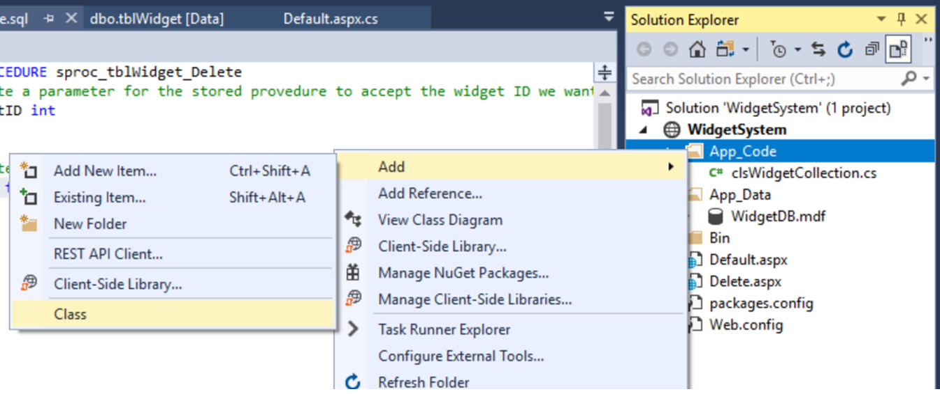
For the name of the class enter clsDataConnection
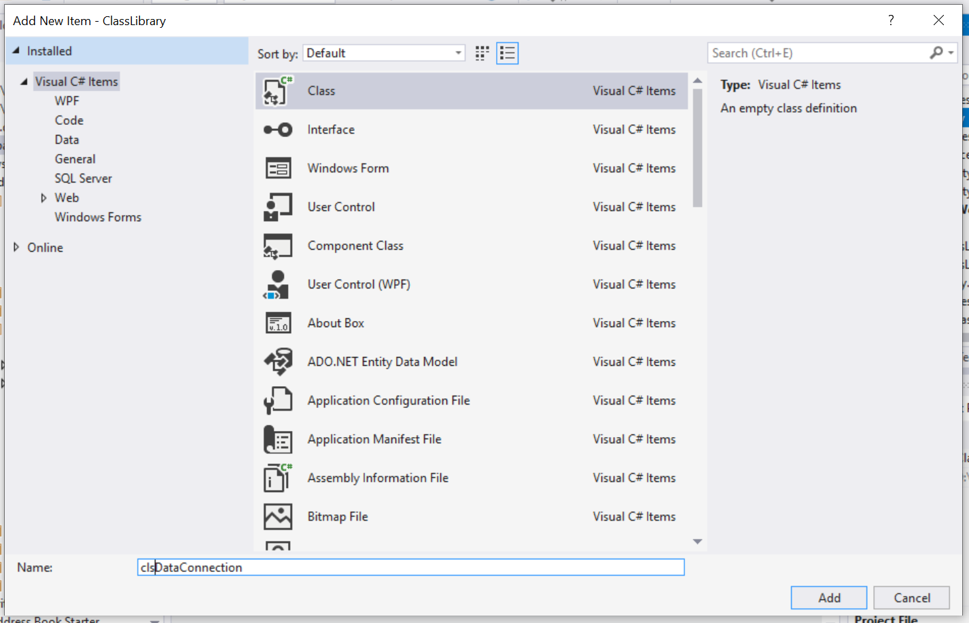
Press OK.
As with the first class it will create some code automatically in this case we want to replace it all.
Highlight the code in the class file created for you and delete it all.
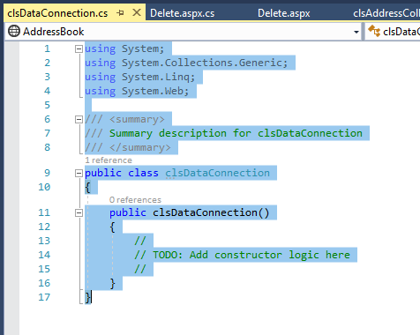
Next obtain the code for the class file from the module web site.
Paste it all into this blank class file...
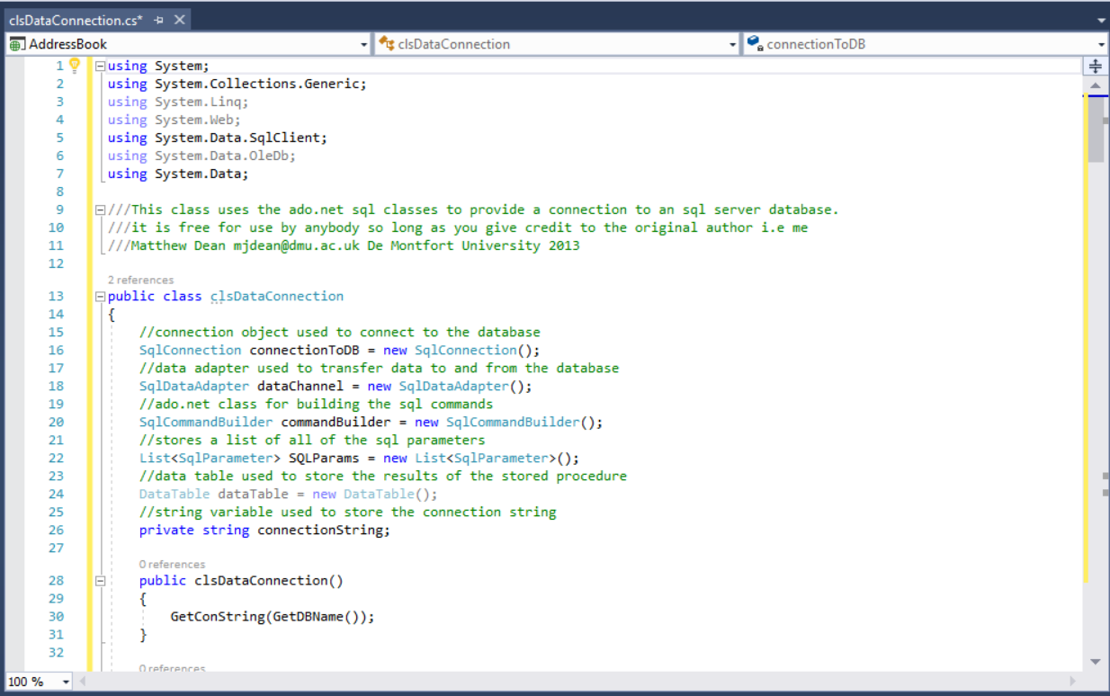
Close and save the class definition. It should be listed in the solution explorer.
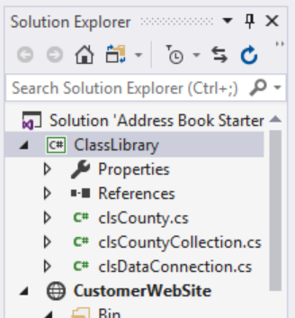
The new code for the constructor of clsCountyCollection is as follows…
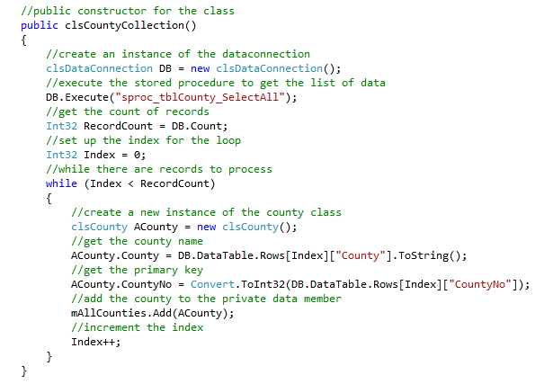
At this stage you will now have some failing tests...
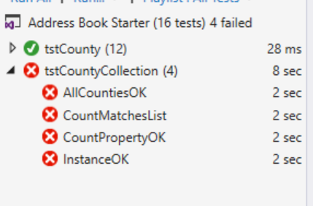
So what is going on?

Azure Connect
In order for your code to connect to Azure we need to provide it with the name of your server, then name of your database, your username and password.
If you look at the settings in the Azure Portal for your database...
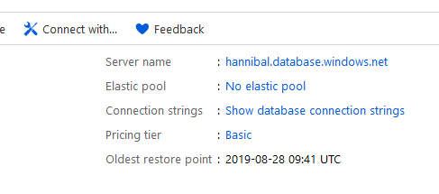
You will see a section for connection string, which will look something like this...

Connection Strings and Public Git Repositories
In order for this to work you need to replace the sections marked {username} and {password} with your own credentials.
So here is the problem. If you add this code into your data connection and place it into a public repository, your plain text user name and password is visible for all to see.
Even if you were using a private repository it likely still isn’t a good idea to store these details as plain text.
To get around this problem a program has been written called Azure Connect, available from the module web site.
When you run the program you will see the following interface...
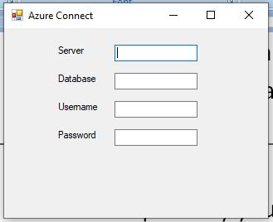
Enter here the details required by each field...
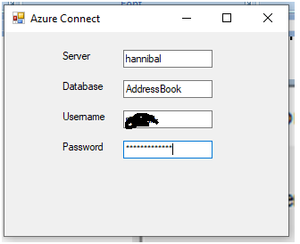
Run your tests again and if everything has gone to plan you should have two failing tests…
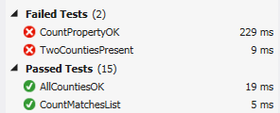
So now what is the problem?
The problem is that we no longer have two test records hard coded into the constructor we now have 72 records actually stored in the database.
The test for the count property needs to be modified like so…
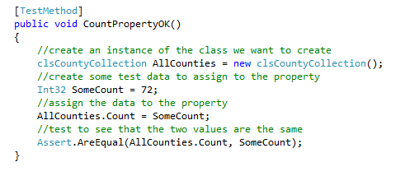
Clearly if Rutland becomes part of Leicestershire or a new county is declared at some point this test will fail (but it will do for now!)
Lastly the following test is actually redundant…
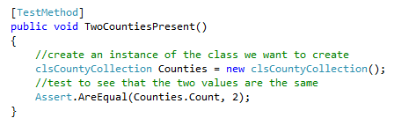
Rather than deleting it though highlight the code and press Ctrl – K – C to comment the block out in case you do need it later. (Ctrl – K – U reverses the block commenting.)
Run your tests and they all should pass…
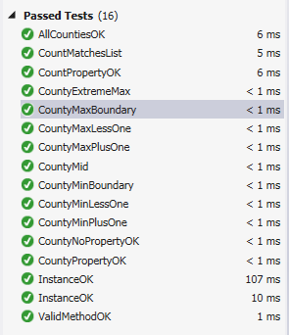
If you run the form now, you should see the drop down list populated with the data from the database.
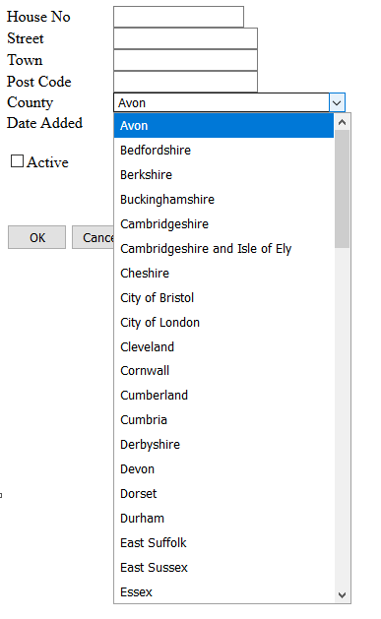
It is worth spending a bit of time to think about what has been achieved here.
We have:
- Taken a class diagram
- Created classes from that diagram
- Implemented methods and properties
- Linked the code to the database
- Linked the resulting code to the presentation layer
- Built a test project allowing us to be reasonably confident that the code is correct

